DAY 11

Q21: Write a program to display the month name and number of days using switch-case for a given month number.

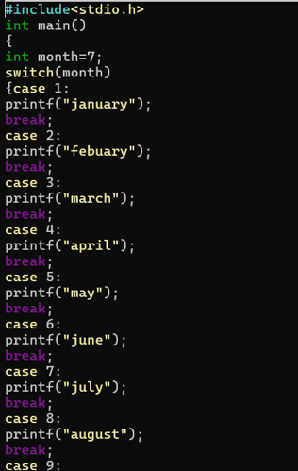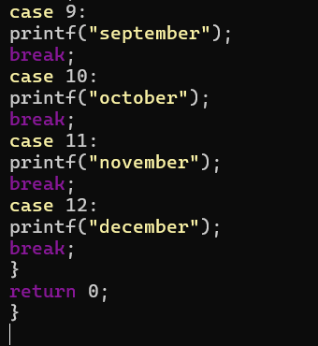

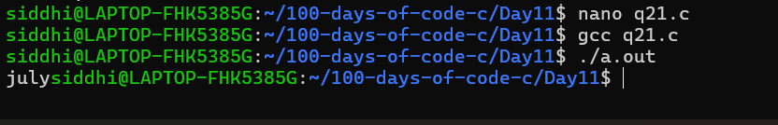

Q22: Write a program to find profit or loss percentage given cost price and selling price.

